Student Enrollment and OnBoarding System

**Step 1:-** Create a New Org For This Project.

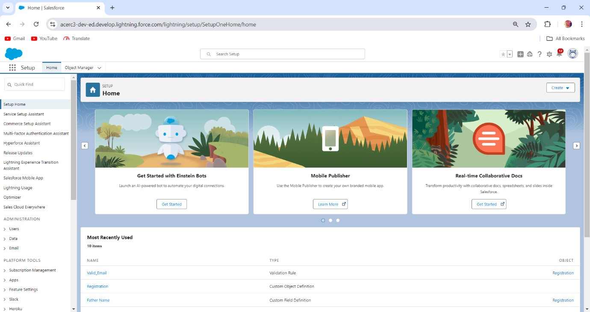

**Step 2:-** Create a Salesforce Lightning App Named as

# “Student Enrollment & Onboarding System”

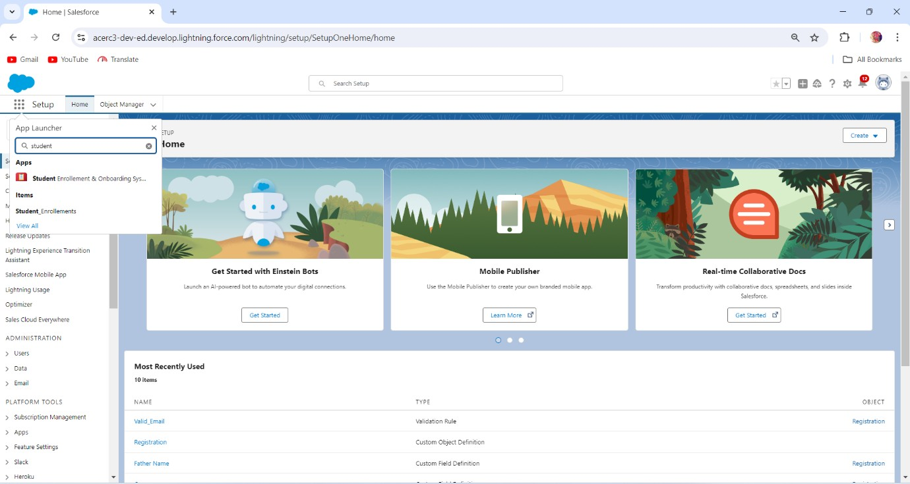

**Step 3:-** Create all the Objects.

1. Home (Custom Home Page)
2. Registration (Custom Object)
3. Student Enrollment ( Custom Object)
4. Course ( Custom Object)
5. Payment ( Custom Object)
6. Case
7. Report
8. Dashboard

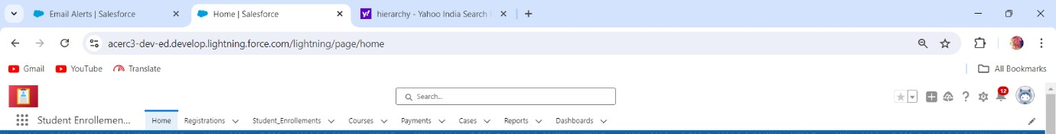

**Step 4:-** Create All Fields Related To this Object.

1. Registration
   * *Registration I’d (Required)
   * *Student Full Name
   * *Date Of Birth
   * *Email Address
   * *Phone
   * Gender
   * *Father Name
   * Description (Optional)
   * (Lookup With Course)

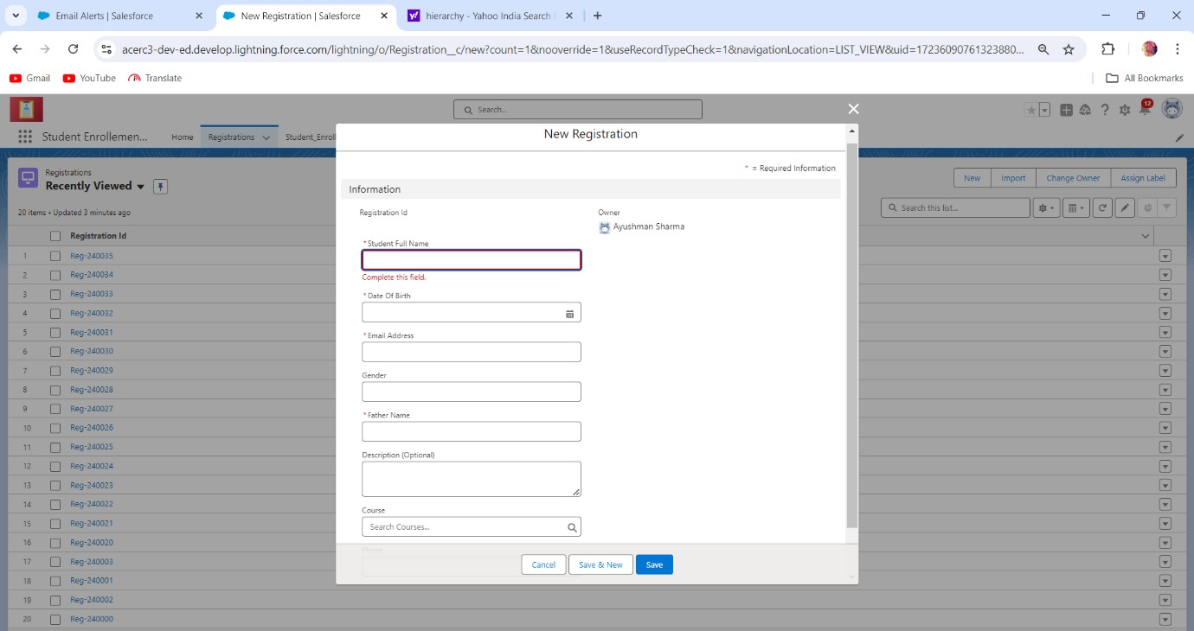

1. Student_Enrollment
   * *Student I’d
   * *First Name
   * Middle Name
   * *Last Name
   * *Date Of Birth
   * *Student Email
   * *Gender (Picklist)
   * *Phone Number
   * Whatsapp Number
   * *Father Name
   * *Father Number
   * Mother Name
   * Mother Mobile
   * *Document (multi-Picklist)
   * Last Qualification
   * Address
   * *(Lookup With Registration)

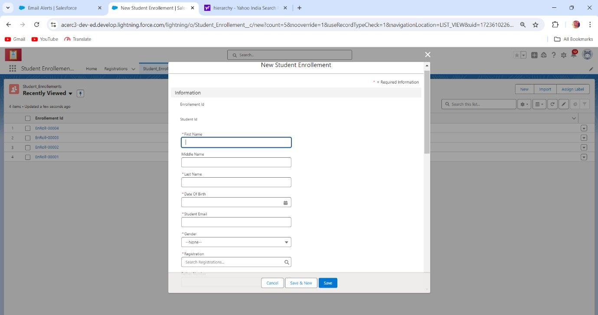

1. Course (Object)
   * Course I’d
   * *Course Name(Picklist)
   * *Duration (In Month)
   * Start Session In Year
   * End Session In Year (Expected)
   * Description (Optional)
   * (Lookup With Registration)
   * (Lookup With Student Enrollment)

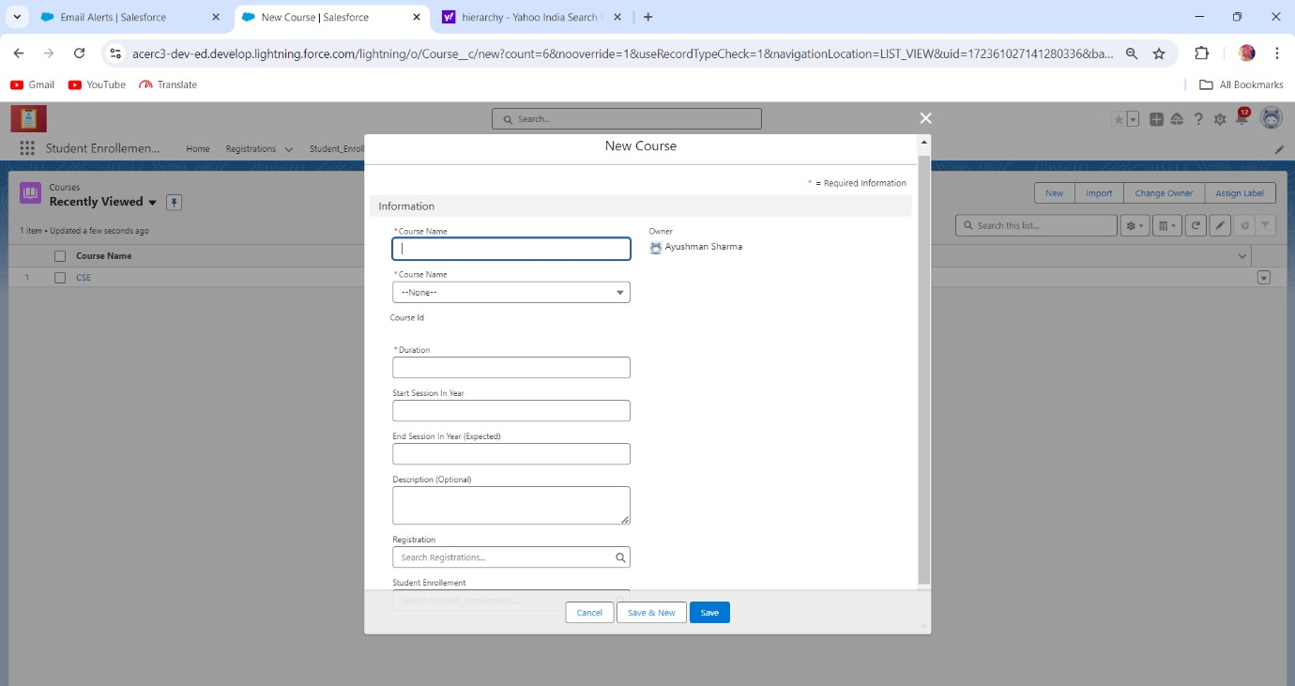

1. Payment (Object)
   * Payment I’d
   * Payment Date
   * *Amount
   * *Due Payment
   * *Mode (Picklist)
   * *Payment Status (Picklist)
   * Description (Optional)
   * (Lookup With Student Enrollment)
   * *Receipts Receiving Email

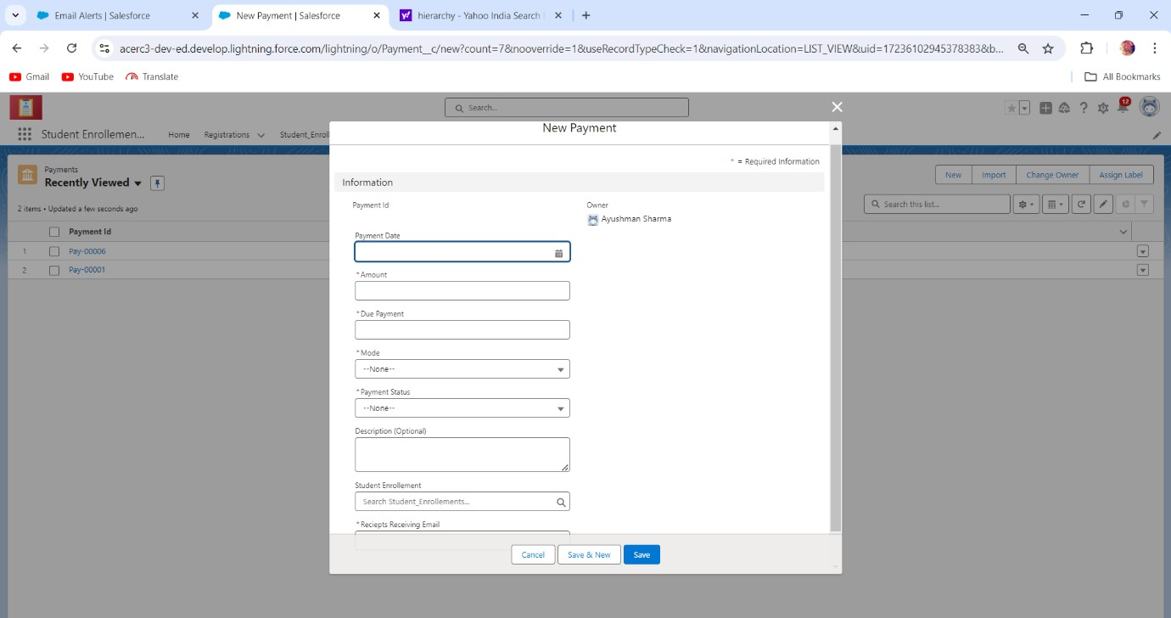

**Step 4:-** Create users and Create Profiles that given Below

User (Standard user) “Principal Name” (Profile Name - Principal) User (Standard user) “HOD Name” (Profile Name - HOD)

User (Standard user) “Professor Name” (Profile Name - Professor) (PRINCIPAL USER’S )

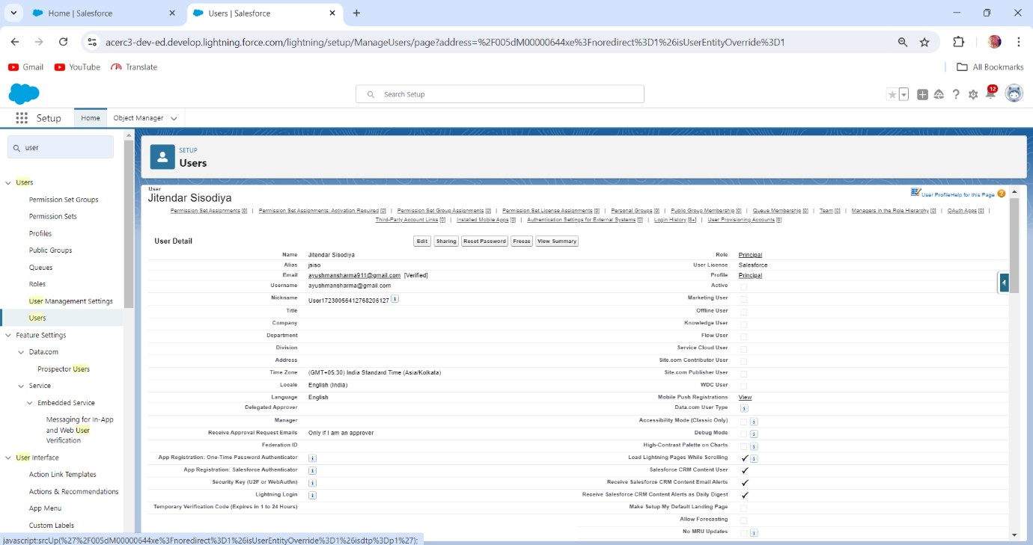

(ALL USER’S )

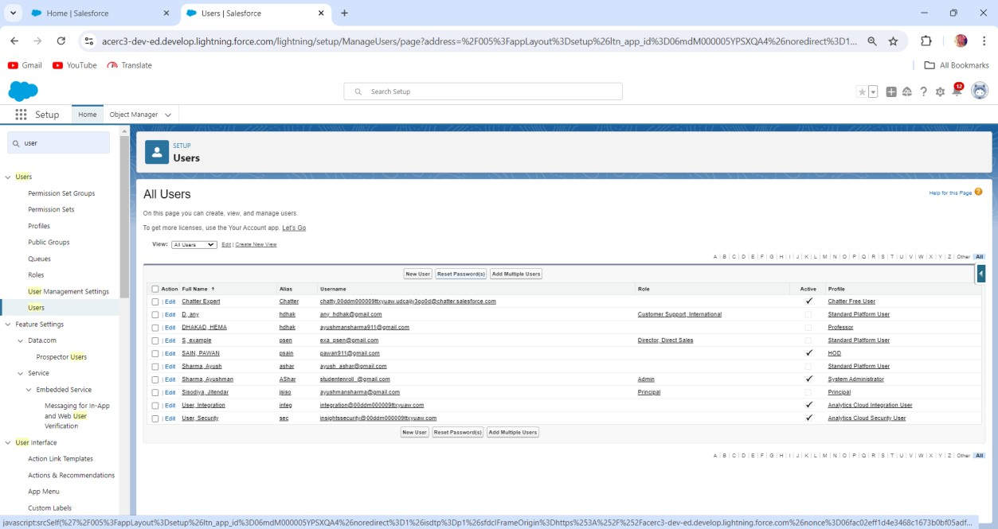

**PROFILES**

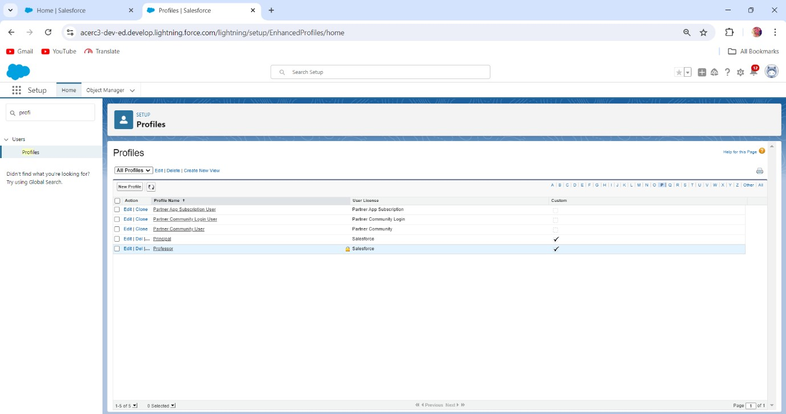

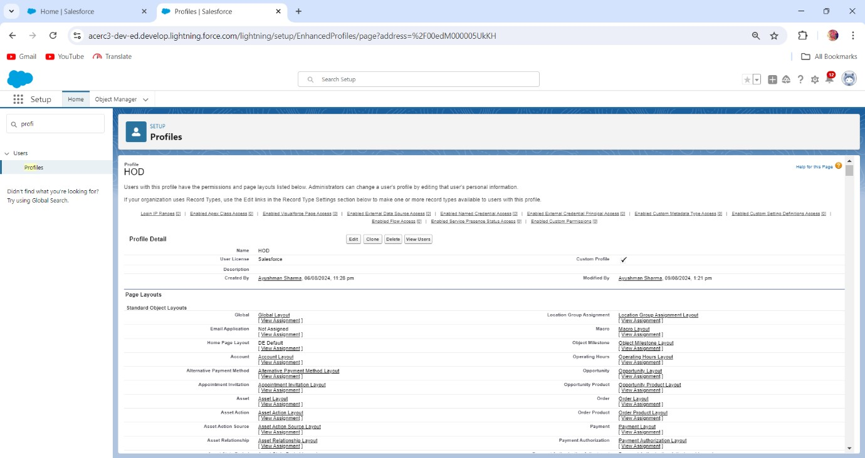

**Step 5:-** Distribute Security accordingly

1. Object Level permission
2. Field level permission
3. Record level permission
4. Permission set
   1. Object Level Permission

|  |  |  |  |
| --- | --- | --- | --- |
| Object | Principal | HOD | Professor |
| Registration | Full | Read | Read |
| Student Enrollment | Full | Read (limited update) | Read |
| Course | Full | Full (within department) | Read and Update |
| Payment | Read | None | None |

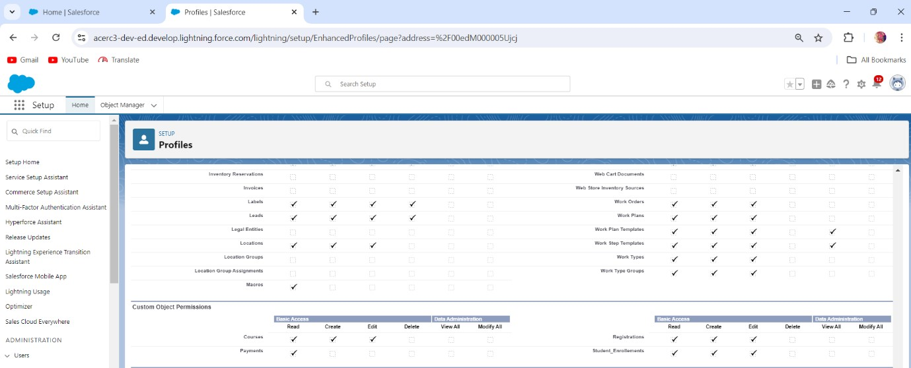

* 1. Field Level Permission

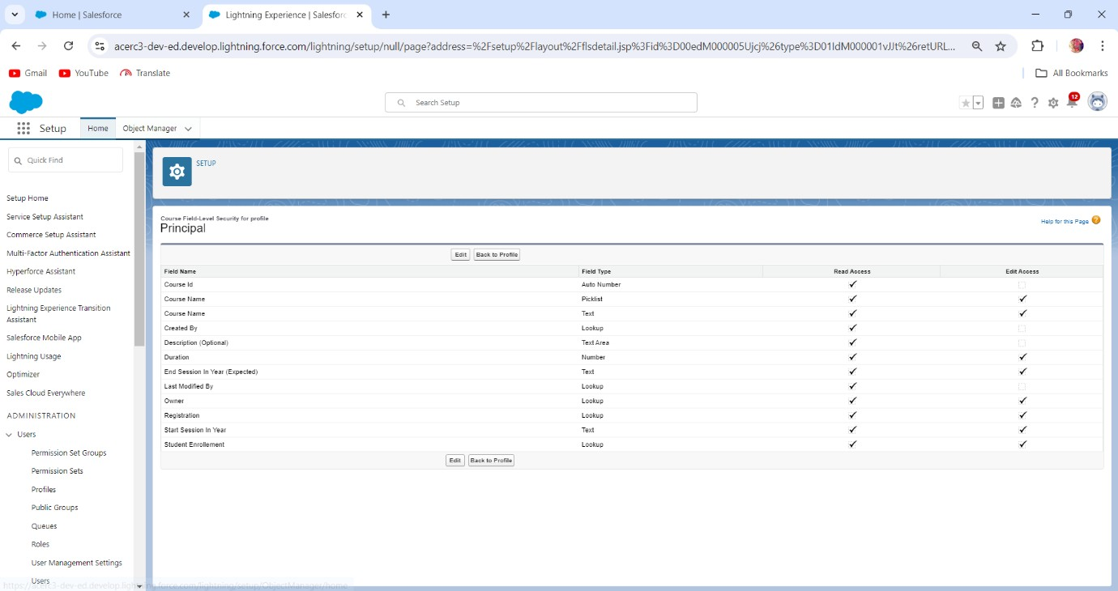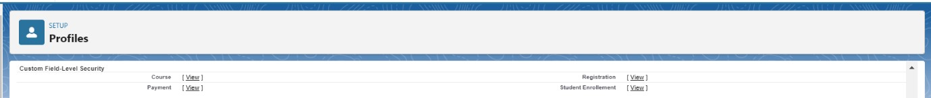

* 1. Record Level Permission

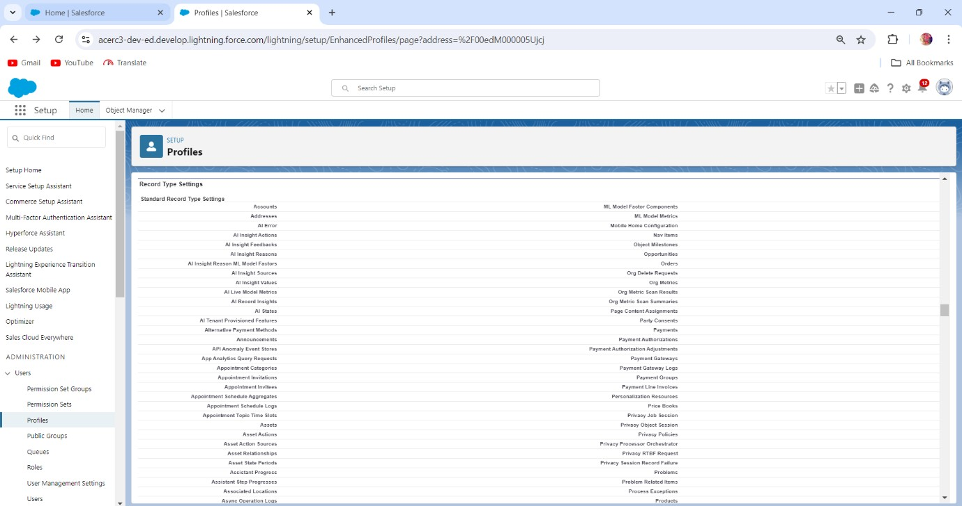

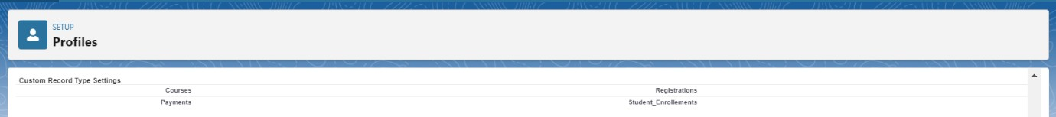

* 1. Permission Set

**Step 7:-** Role and Hierarchy.

# Admin—-> Principal—-----> HOD > Professor

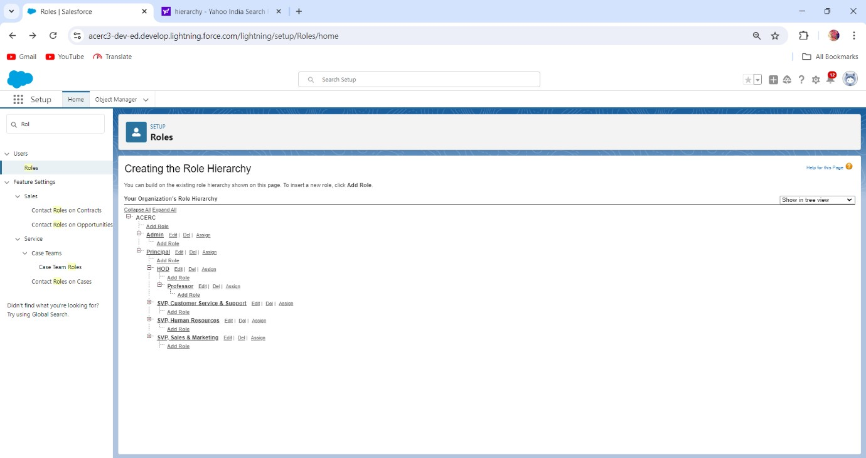

**Step 7:-** Automations

1. Registration confirmation (At the time creation)
2. Enrollment confirmation (At the time of creation/Updating/edit)
3. Payment Receipt (at the time of record generate)

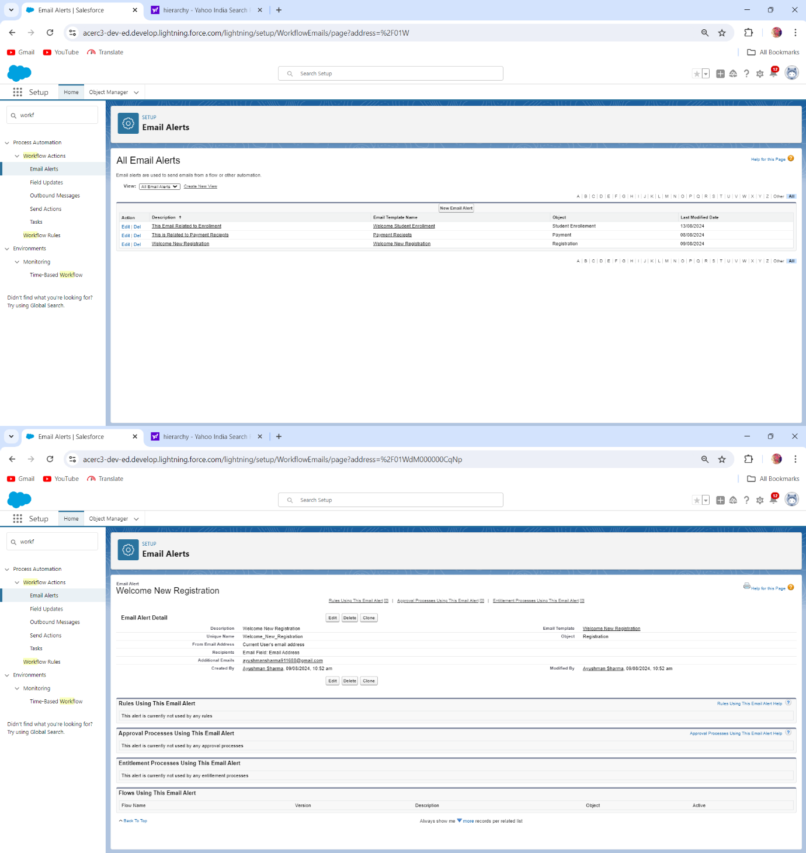

# Step 8:-

1. Create report and Dashboard for the Registration Object
   * Report:-

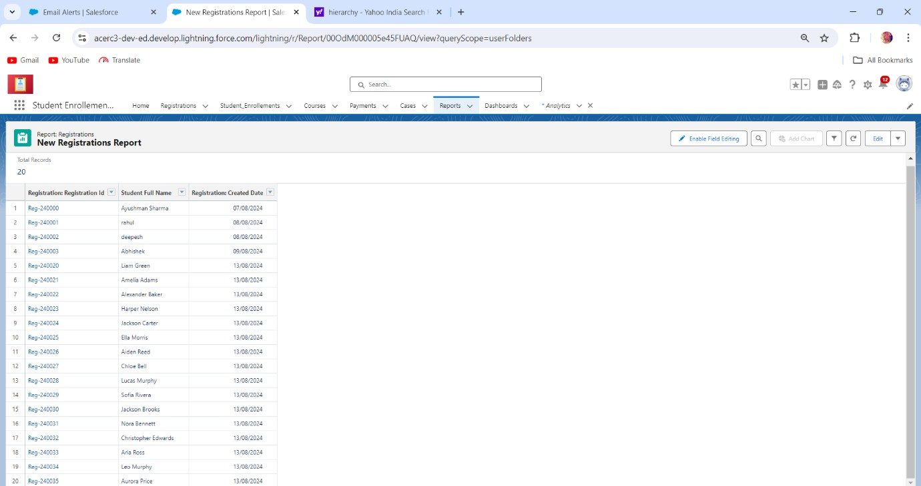

* + Dashboard:-

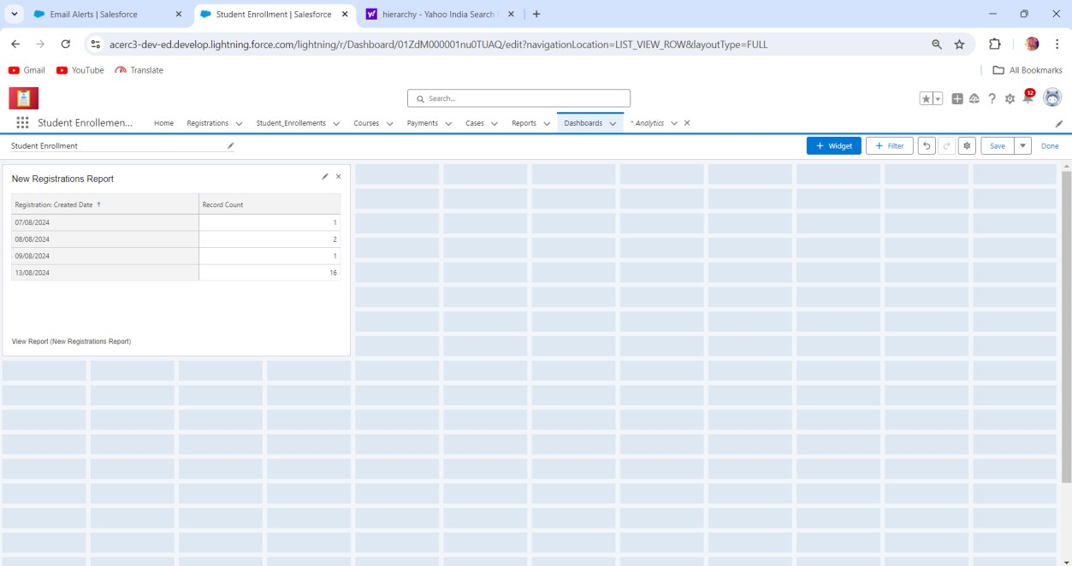

1. Student Enrollment Object for analyse the previous year data trends, new Admission. Everything will be in the context in Profit.